Curriculum Vitae
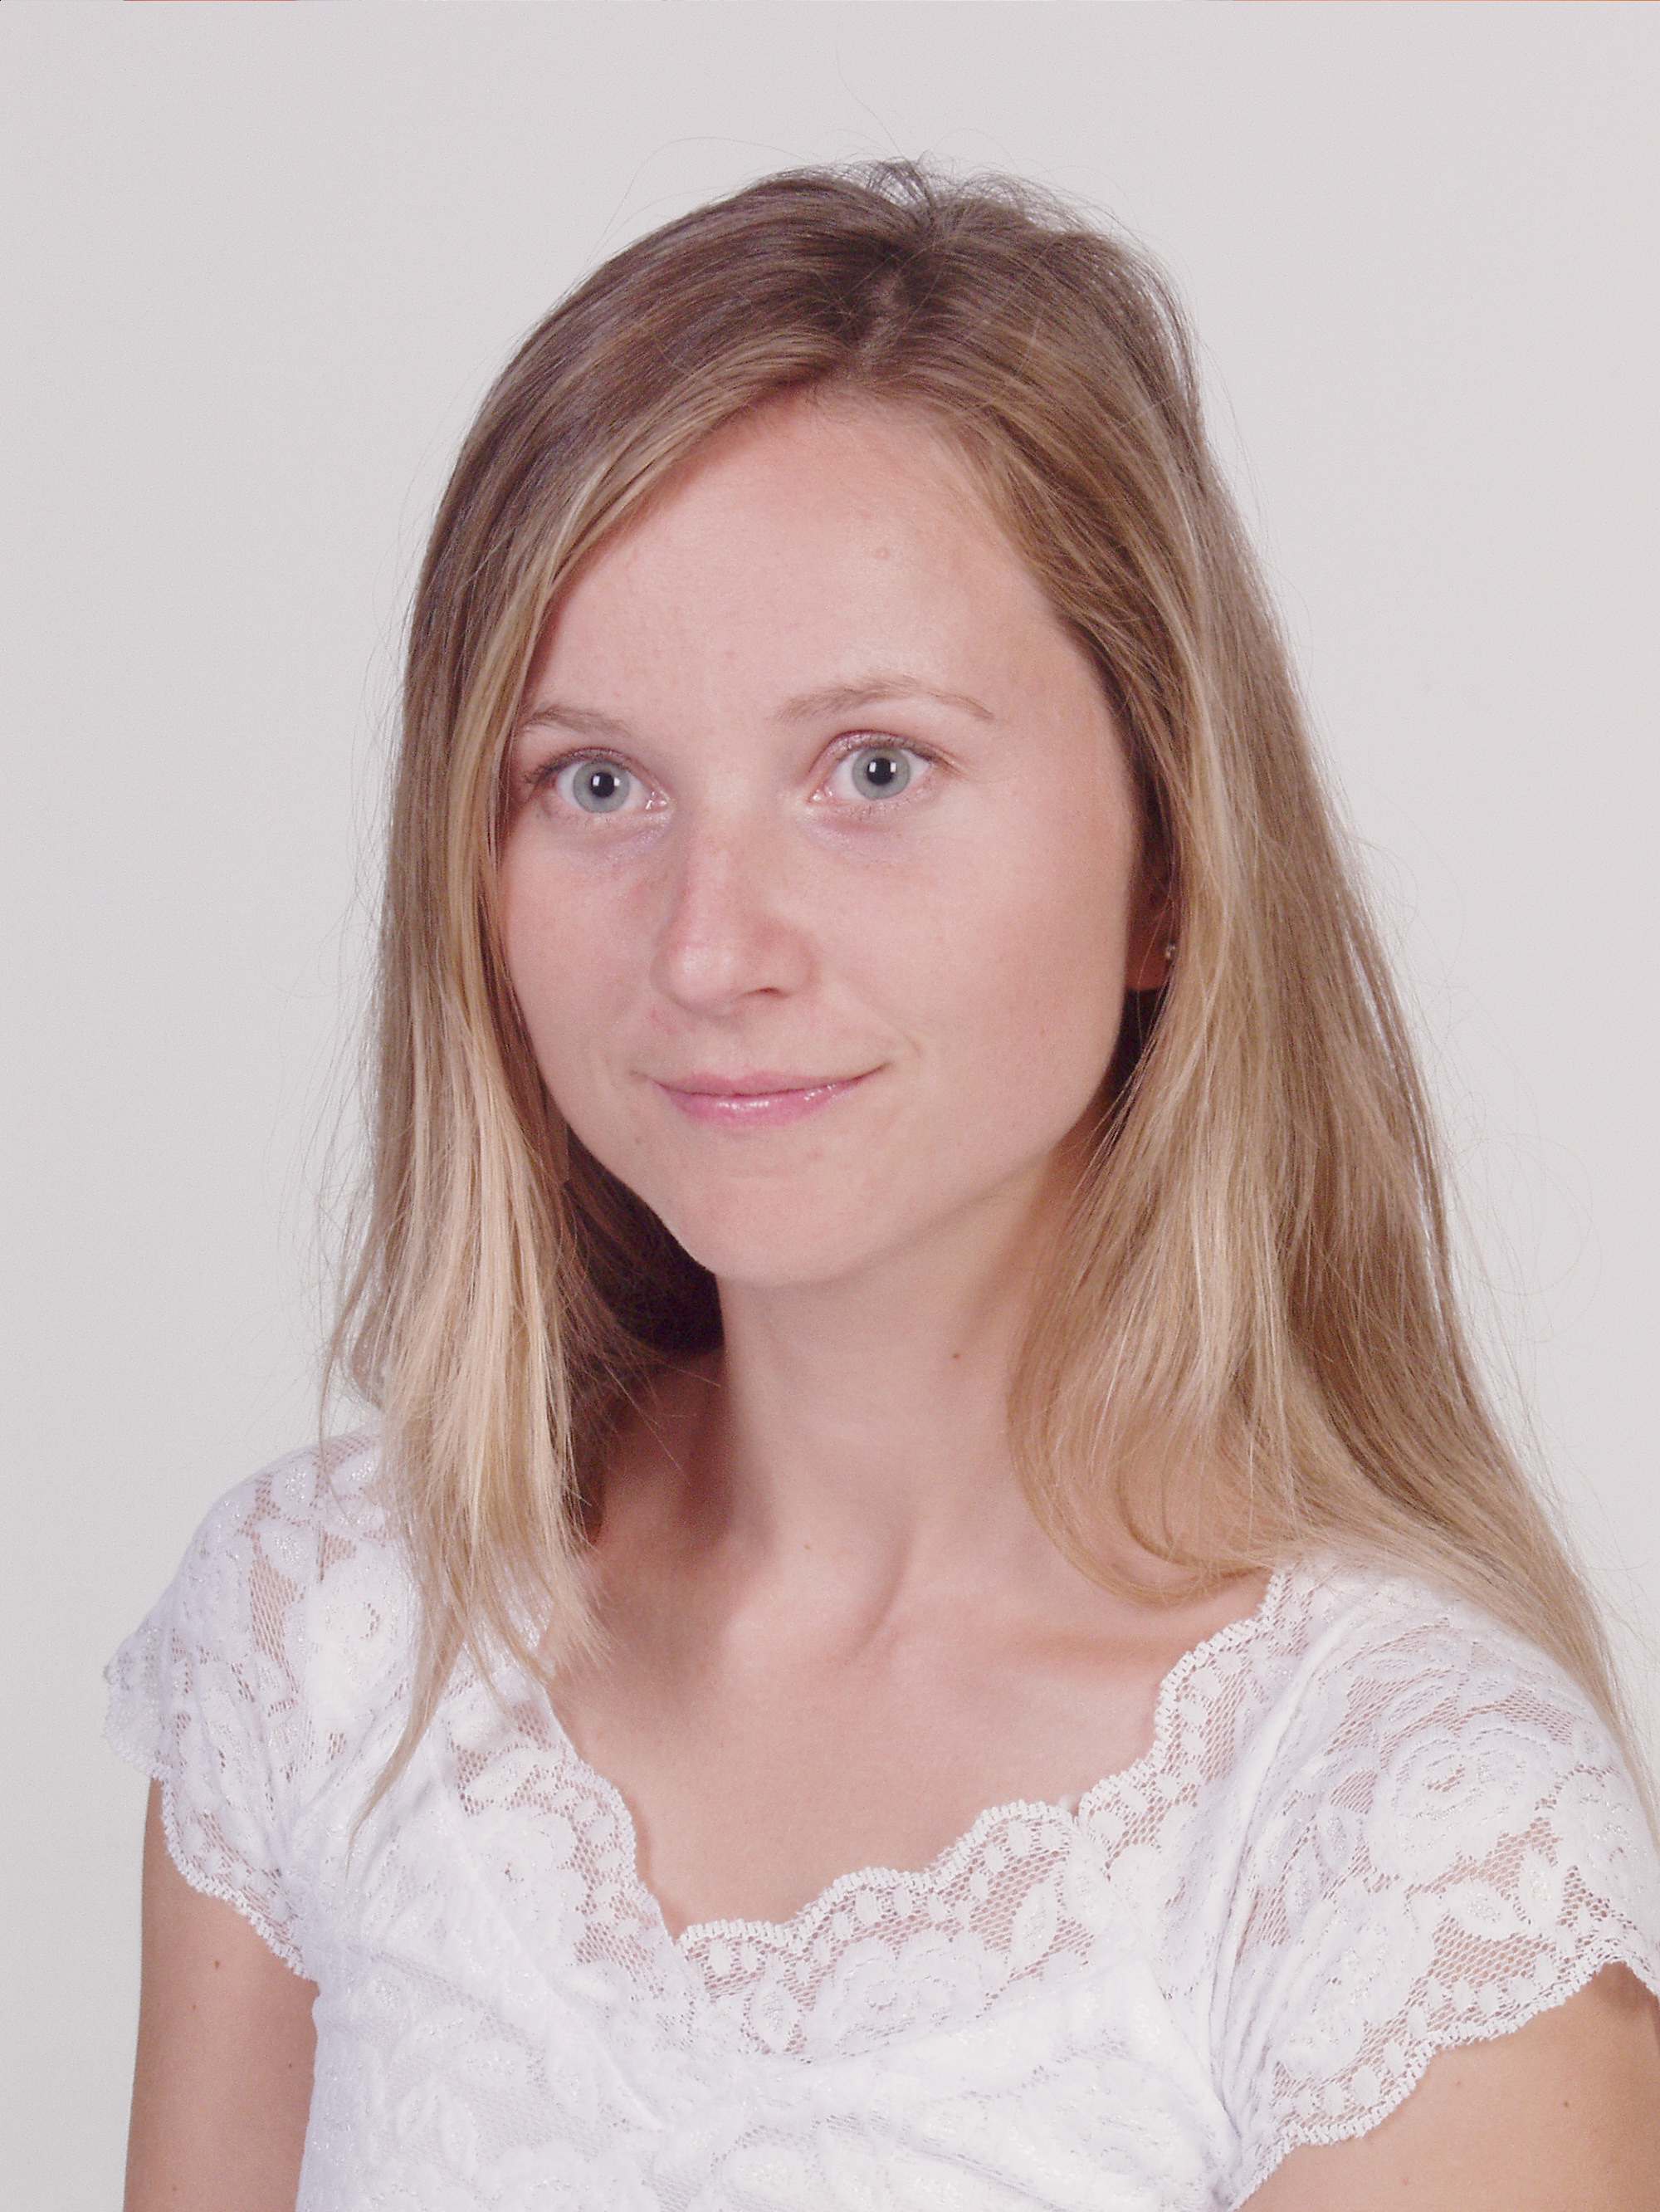

AleksandraKwaśniewska

_______________________________________________________________________
Personal Data

Date and Place of Birth 13.03.1978, Bielawa, Poland
Address: St -Lievenslaan 21, 9000 Gent, Belgium
E-mail o_ska@yahoo.com
Telephone number: 0477556923
Marital status: single

Nationality: polish
___________________________________________________________________________
Education

2002 – 2003 Scholarship Master Program at the University of Gent, Belgium
English Philology, Translation Department
2001 – 2002 Postgraduate Studies for Translators at the University of Wroclaw, Poland
2001 - 2003 Master Studies at the University of Wroclaw
English Philology, Translation Department
2000 – 2001 Business English Course, Yazigi School, Florida, USA
1997 – 2000 Bachelor Studies at the University of Wroclaw
English Philology, British Literature Department
1993 – 1997 High School in Bielawa, Poland, languages extended class
___________________________________________________________________________
Experience

2001 – 2002 Translator at the international conference „Poland in European Union”,
City Council, Wroclaw, Poland
2001 – 2002 Member of the International Cooperation Department at the University of Wroclaw,
Taking care of the Erasmus Students
2000 – 2002 Interpreter and translator for the Danish Consulting Group „Carl Bro”.
Organizing the meetings, taking care of the Danish guests
2000 Translator at the international conference: New Technological Solutions,
Translation Agency „Yellow”
___________________________________________________________________________
Knowledge of the foreign languages

English (fluently)
French and German (basic)
__________________________________________________________________________________________
Interests

Jazz - Belgium: Studies at the Jazz and Light Music Department, Gent, Belgium
Far travels- fascination with Africa
Cinema – Kusturica movies
___________________________________________________________________________

